ADITYA SINGH
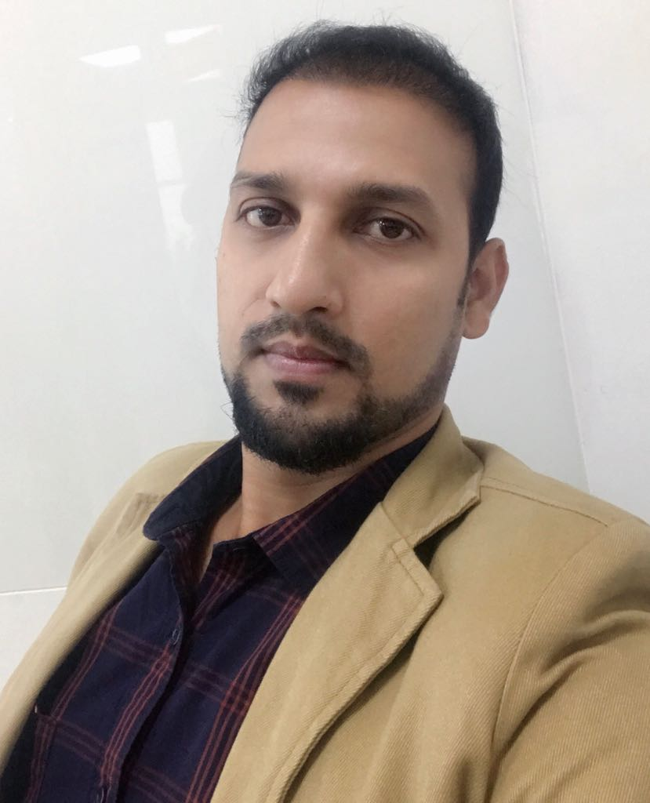
Contact - +918983245609
Email id – adityasingh1869@gmail.com

Project Assistant Manager with 3.6+ years of experience in project management & commissioned more than
350 MW Renewable Project in state of Maharashtra & Gujarat. I am interested to invest my skills in best way
for achieving company’s goal.

EXPERIENCE

- Orange Renewable Pvt Ltd (20th April, 2016 onwards…)
- Working as Assist. Manager in projects (Solar) in Orange Renewable Pvt Ltd my arrays of work are as follows…
- Coordinated the supportive services between departments through organized weekly meetings.
- Providing support to intra department like finance, engineering, procurement, Business Development.
- Responsible for managing the financial cycle including bidding and proposals, purchase orders, and review and approval of vendor invoices.
- Vendor development & sourcing management.
- Identified and worked to remove barriers to successful completion of the overall project, with particular emphasis on resolving issues with subcontractors.
- Coordination with stakeholder and vendor in order to meet project execution plan.
- Facilitated and coordinated the work of multiple project teams engaged in the establishment and implementation of new projects to support the Project Head.
- Identifying risk & issue in ongoing project and their mitigation plan.
- Project scheduling and tracking throughout the project.
- Provided timely project status updates to the Project Head.
- Maintain and update Project database.
- Create and sustain good working relationships with internal and external partners.
- Streamlined the current day process used to resolve closure issues in bulk, as well as older issues.
- Preparation & presentation of project status to Project head on weekly basis.
- Created monthly progress reports and communicated results to appropriate staff
- Manpower allocation and scheduling.
- Tracking the engineering drawing approval required to smoothen project execution on site.
- Coordination in testing of manufactured equipment and arranging MDCC for tested equipment.
- Ensuring timely delivery of resource and engineering equipment on site in support of timely closure of project.
- Assisting BD team to get project fusibility report & grid connectivity from concerned utility.
- Tracking all list of utility & statutory approval required for project execution.
- Providing support & tracking of Land acquisition status right from Due diligence followed by sale deed & its conversion to non-agriculture land.
- Coordinating and providing support to liasioning team to accord approval of forest land (if any).
- Current Projects
  - Maharashtra 100 MW PV Solar Project under scheme of JNNSM sanctioned by SECI(Commissioned)
  - Gujarat 40 MW PV Solar Project under scheme of JNNSM sanctioned by SECI(Commissioned)

- Gamesa Renewable Pvt Ltd (6th Aug,2014 to 18th April,2016)
- Worked as Project Coordinator (Wind) in Gamesa Renewable Pvt Ltd. my scope of work are as follows…
- Identify scope and all major milestones based on the contract.
- Update related information over Slip on milestones & Delays affecting the activities and milestones.
- Identify resources at site level that required to deliver the project.
- Responsible for all detailed planning related to specific project and maintaining the plan throughout the project.
- Evaluate dependencies and consequences of activities.
- Ensuring the easy availability of equipment to team as prioritized for project.
- Communicate time recording instruction to all employees
- Ensure the document plan for the project is in place and how to communicate information

- Projects
- CLP (Client) 60MW Project for wind farm development at Jath, Sangli-Maharashtra as a project coordinator.
- Energon (Client) 30 MW Project for wind farm development at Jath, Sangli-Maharashtra as a project coordinator
- Koral-125 MW project for wind farm development at Koral, Osmanabad- Maharashtra.

ACADEMIC PROFILE:
Pursued Bachelor of Engineering in Power from National Power Training Institute, Nagpur
Course(Duration) | Background | Board/University | Percentage
B.E.(2010-14) | Power Engineering | Nation Power Training Institute, Nagpur | 66.83 %
H.S.S.C.(2007-09) | Maths & Science | JAC, RANCHI | 72.20 %
S.S.C.(2007) | --- | JAC, RANCHI | 79.20 %

COMPUTER SKILLS:

- Well familiar with software like Photoshop, Paint, Nero & various daily needed software
- Operational knowledge of Ms Power point, Ms Word, Ms Excel ,Ms Project, AutoCAD, PV Syst.

SUBJECT OF INTEREST:

- Thermal Engineering, Steam Generator & turbine
- Renewable energy, PV Module, Wind turbine

LANGUAGES KNOWN:
Speak Read Write
- English :
- Hindi :
- Marathi : Conversational

TRAINING DETAILS:

- Attended 4 week Vacation Training conducted at Koradi Training Centre (MAHAGENCO), Koradi during 13th May 2013 to 07th June 2013
- Many Visits conducted by NPTI to Khaparkheda Thermal Power Station(4*210 MW)

ACHIEVEMENTS:

- Successfully Commissioned 215 MW Wind Project
- Successfully Commissioned 140 MW Solar Project

SKILLS:

- Communication.
- Leadership
- Team management
- Negotiation
- Risk management

LEISURE INTREST:

- Computer games

PERSONAL DETAILS:

- Name : Aditya Singh
- Date of Birth : 25th Oct 1991
- Gender : Male
- Father’s Name : Upendra Kumar Singh
- Mother’s Name : Gyanti Devi
- Permanent Address : Aditya Singh
S/O Upendra kumar Singh
Near Mahadeva Bhawan
New area bypass Chowk
Aurangabad (Bihar)
Pin-824101
- Correspondence Address : Aditya Singh
S/O Upendra kumar Singh
Near Mahadeva Bhawan
New area bypass Chowk
Aurangabad (Bihar)
Pin-824101
- Nationality : Indian

REFERENCES:
- Pramod Shankar Puranik
Assistant Engg. (Civil), MPPGCL
Mob: - +919425839705
- Suman Kumar
Data Manager (C.S Engg.), WIPRO
Mob: - +919643413938

DECLARATION:

I hereby declare that the above mentioned details are true to the best of my knowledge.

Place: New Delhi, Delhi ADITYA SINGH

